Acne is a common inflammatory skin condition that affects the hair follicles and sebaceous glands.
It appears as blackheads, whiteheads, pimples, papules, pustules, or sometimes cysts.
It commonly affects teenagers but can occur at any age.
Causes of acne
• Excess sebum production
• Clogged pores (dead skin cells accumulation)
• Bacterial growth (Cutibacterium acnes)
• Hormonal changes (puberty, PCOS, stress)
• Oily cosmetics
• Poor skincare routine
• High glycemic diet

Treatment
- Cleansers (Twice Daily)
For oily/acne-prone skin:

• Effaclar Gel.
• SHAAN Gel.
• CeraVe Foaming Cleanser.
• Dermactive Acti-Clean.

Avoid harsh soap.

Active Treatment

• Salicylic Acid (unclogs pores)
• Benzoyl Peroxide (kills bacteria)
• Adapalene (regulates cell turnover)
• Azelaic Acid (reduces inflammation & pigmentation)
• Niacinamide (controls oil & redness)

Examples in Egyptian pharmacies:

• Effaclar Duo (+)
• CeraVe Resurfacing Retinol Serum
• Skinoren Cream
• Benzac AC Gel

Use once daily at night (start slowly).

3) Moisturizer (Very Important Even for Oily Skin)

• Effaclar H Moisturizer
• CeraVe Moisturizing Lotion
• Infinity Clear Skin Cream

Apply twice daily.
4) Sunscreen (Morning Only)

Important Tips

• Do not squeeze pimples
• Wash face twice daily only
• Remove makeup before sleep
• Change pillowcase regularly
• Reduce sugary food
•Manage stress
Moisturizer for skin

Dry skin
Characteristics:

• Tight feeling
• Rough texture
• Flaking
• Sometimes itching

Best Ingredients:

• Hyaluronic Acid
• Ceramides
• Glycerin
• Shea Butter
•Panthenol

Pharmacy Examples:

• CeraVe Moisturizing Cream
• Lipikar Baume AP+
• Atoderm Cream
• Eva Skin Clinic Moisturizing Cream

Apply 2–3 times daily

Oily skin
Characteristics:

• Shine
• Enlarged pores
• Prone to acne

Best Ingredients:

• Niacinamide
• Hyaluronic Acid (light texture)
• Oil-free formulas

Pharmacy Examples:

• Effaclar Mat
• CeraVe PM Facial Moisturizing Lotion

Use twice daily

Combination Skin:
Characteristics:

• Oily T-zone
• Dry cheeks

Best Ingredients:

• Lightweight gel moisturizers
• Hyaluronic acid
• Niacinamide

Pharmacy Examples:

• Hydraphase Light
• CeraVe Moisturizing Lotion
•Infinity Hydrating Gel

Sensitive skin:

Characteristics

• Redness
• Burning sensation
• Reacts easily

Best Ingredients:

• Panthenol
• Ceramides
• Madecassoside
• Thermal water

Pharmacy Examples:

• CeraVe Moisturizing Cream.

Avoid fragrance and alcohol

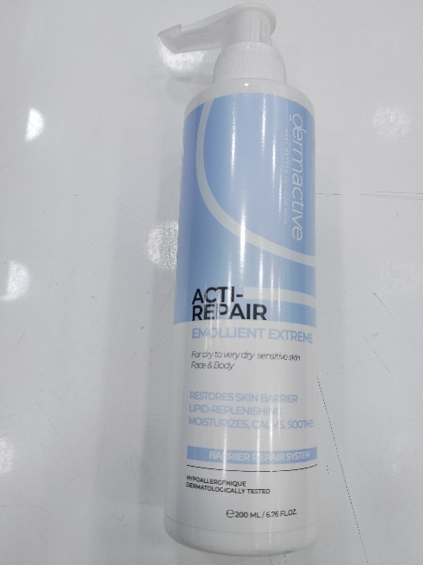
Dry skin products :
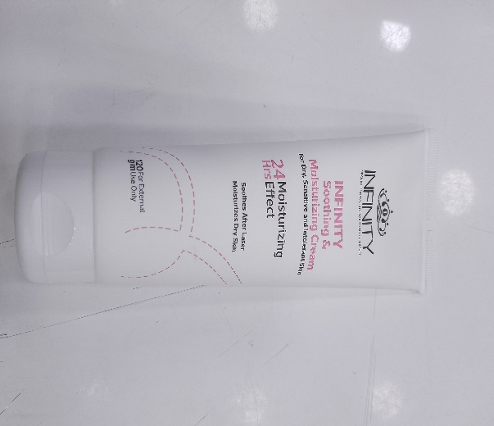
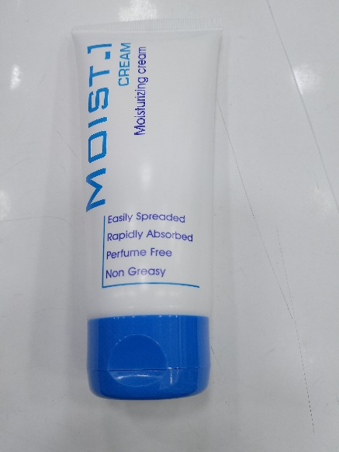

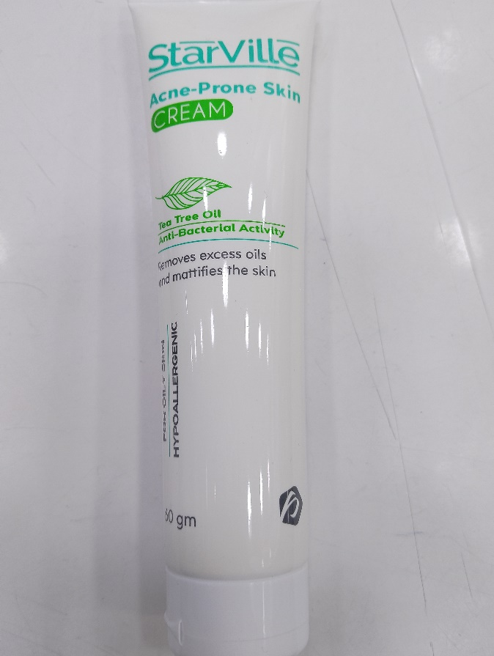

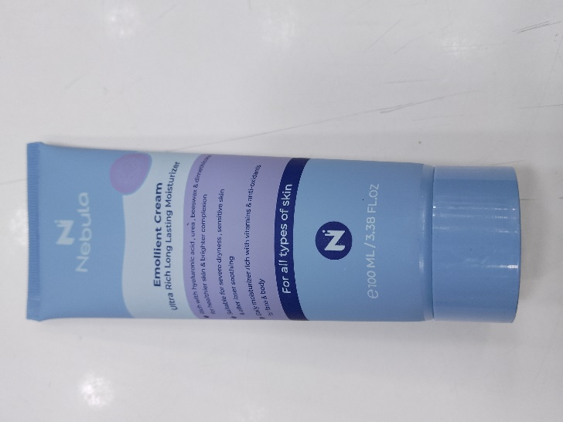

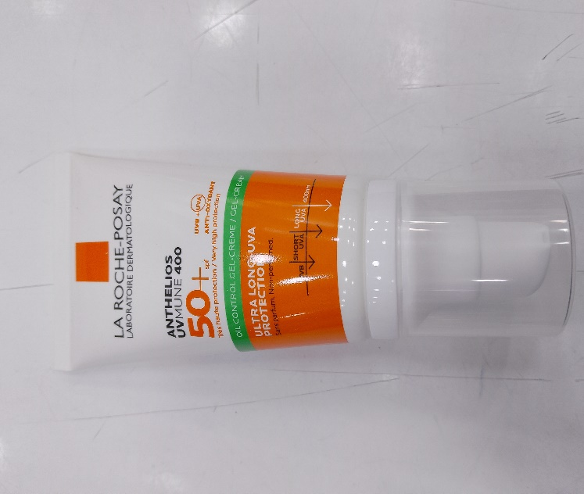
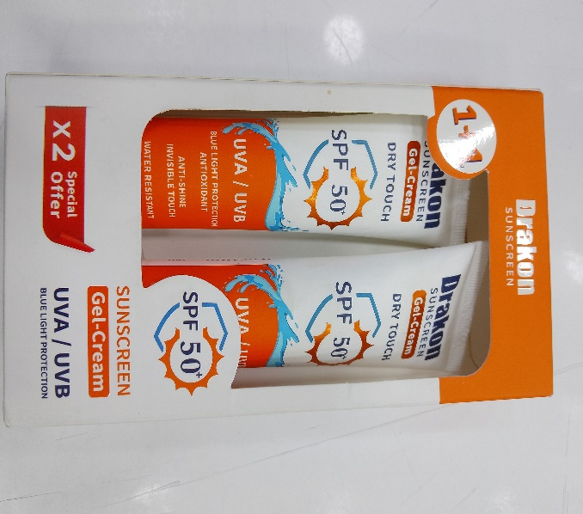

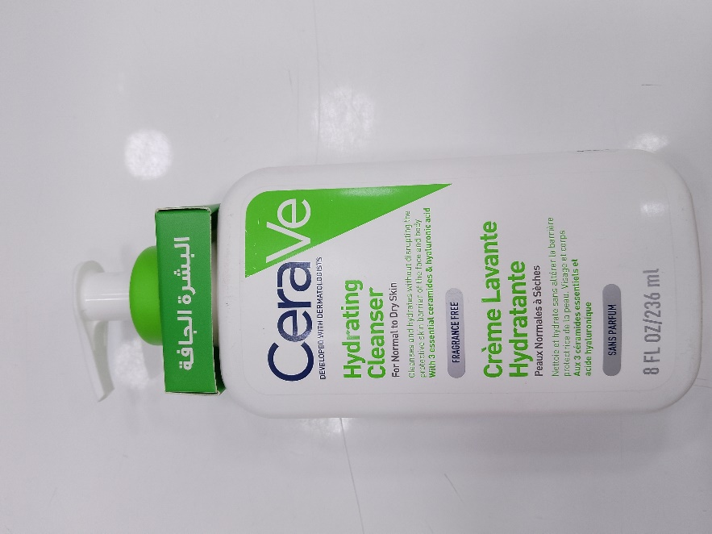
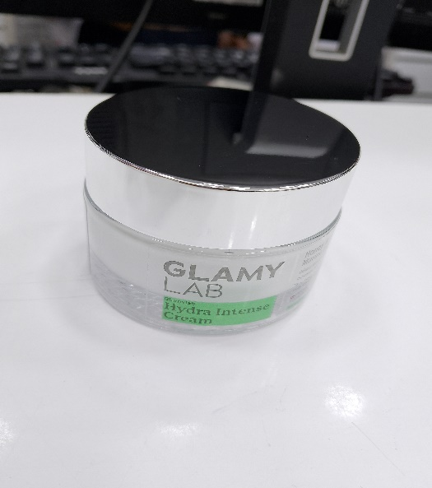
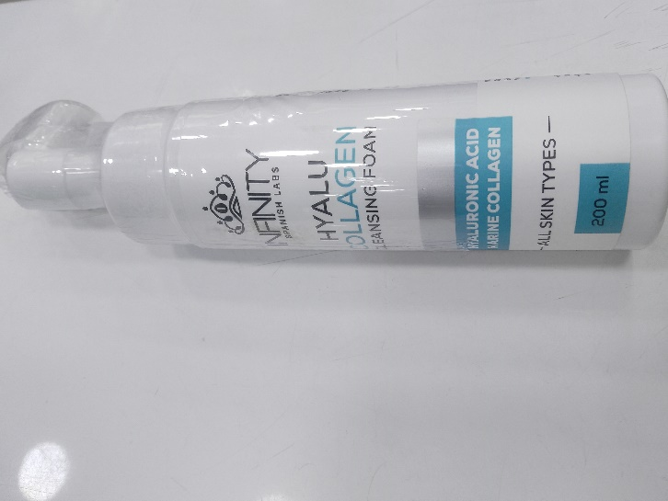

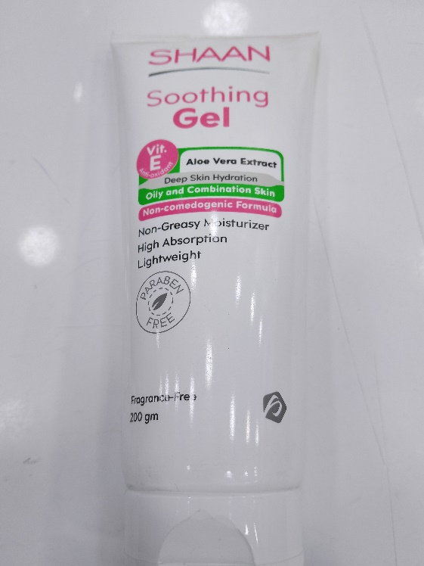
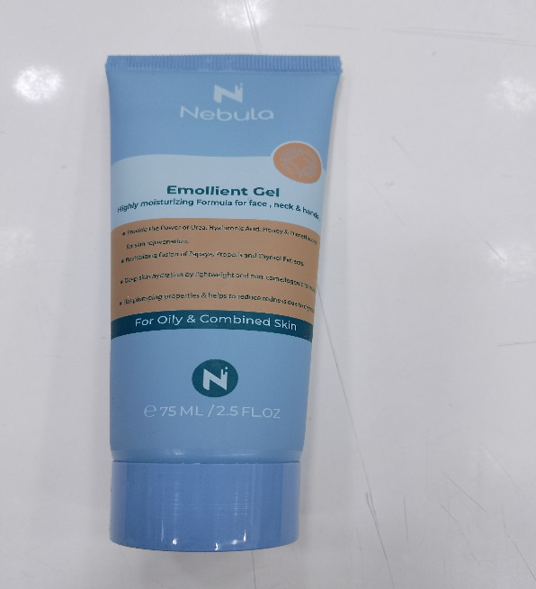
Oily skin:

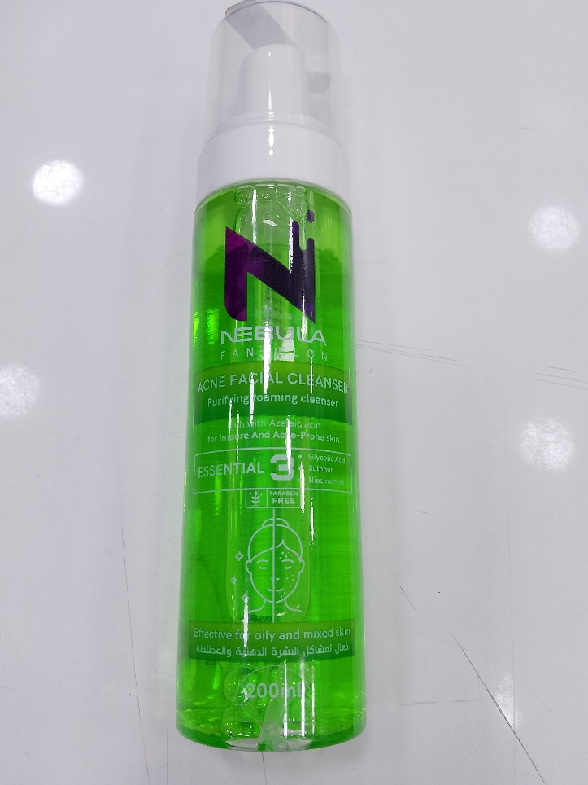

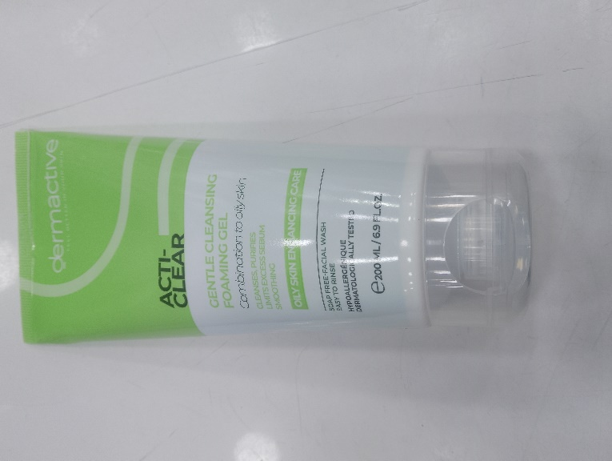

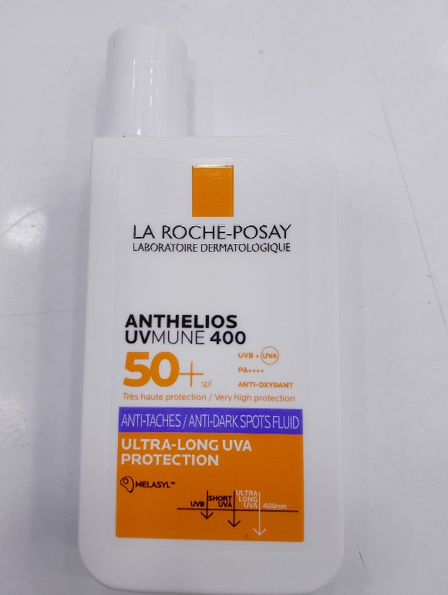

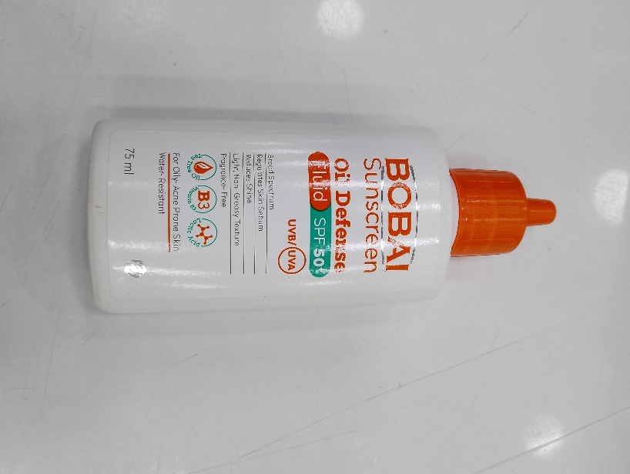

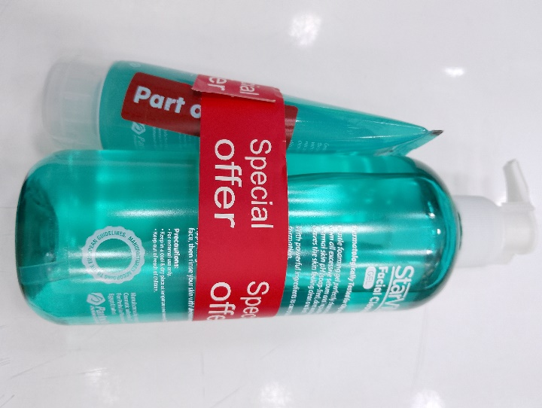

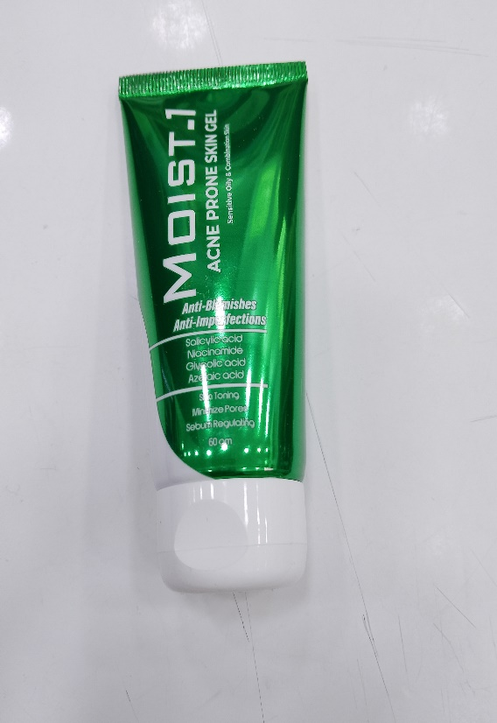

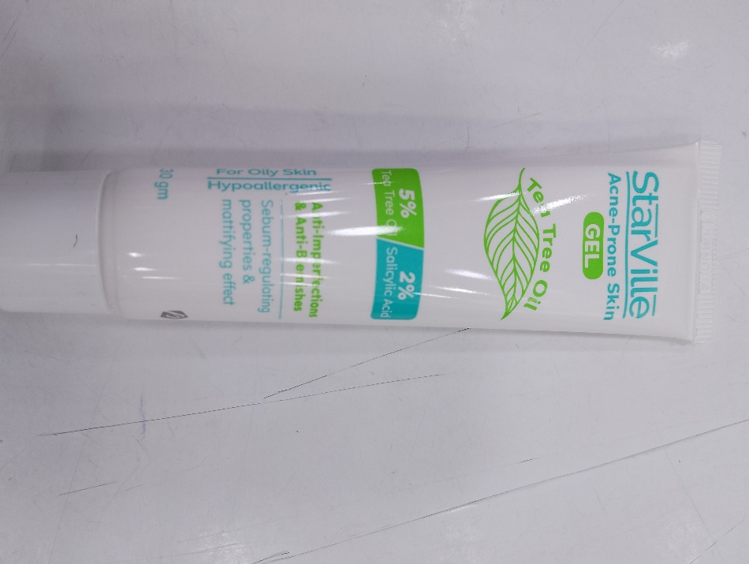

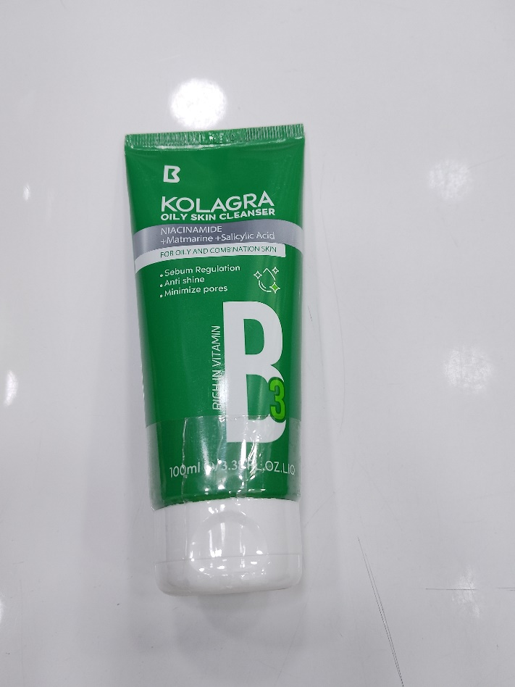
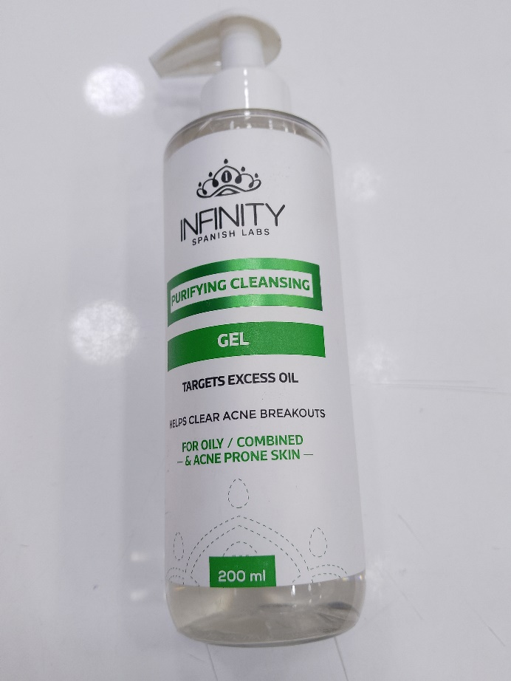

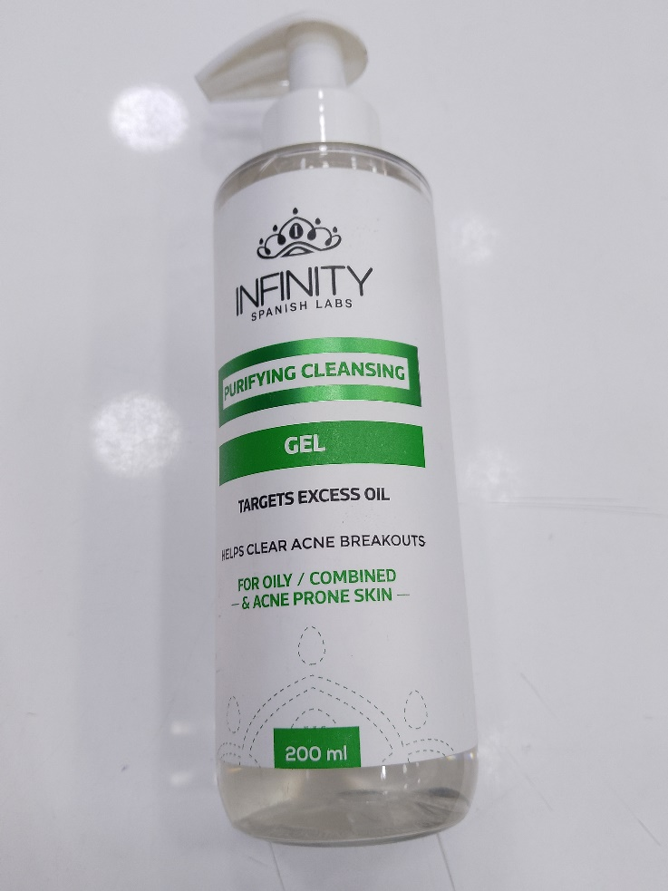
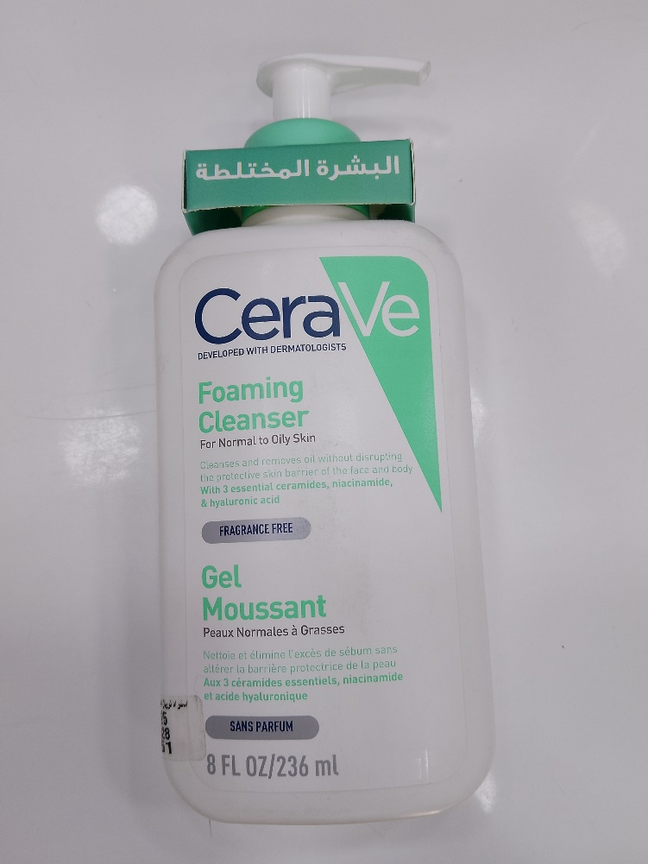
Combination skin

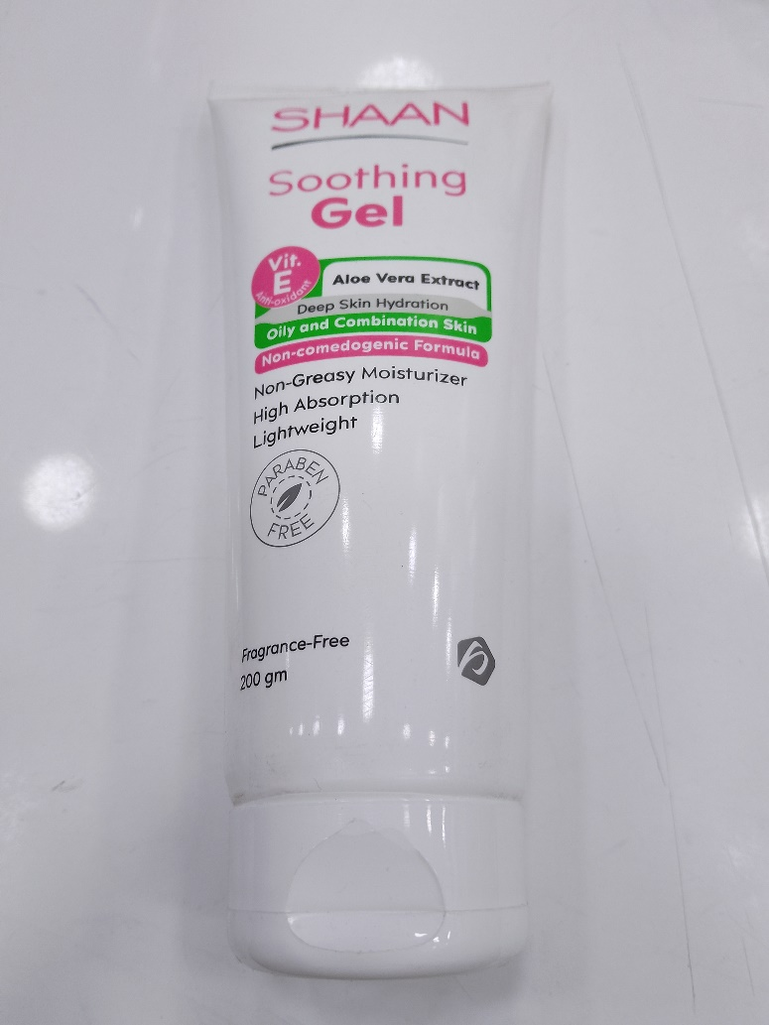
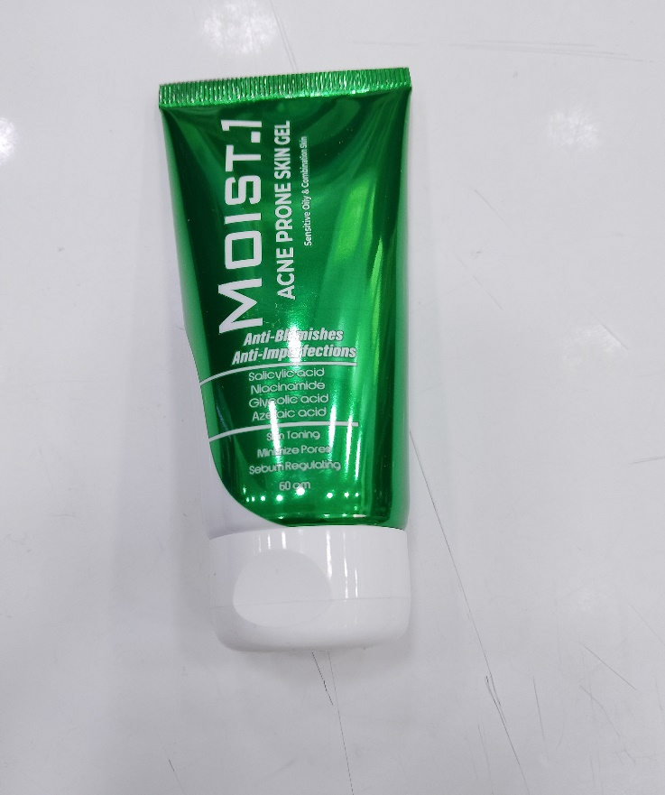

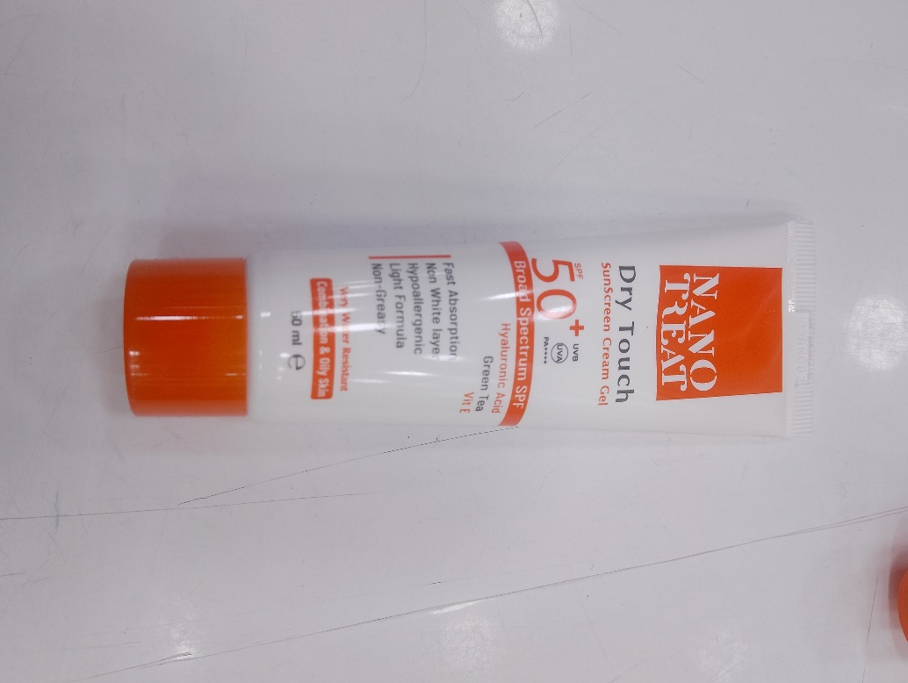

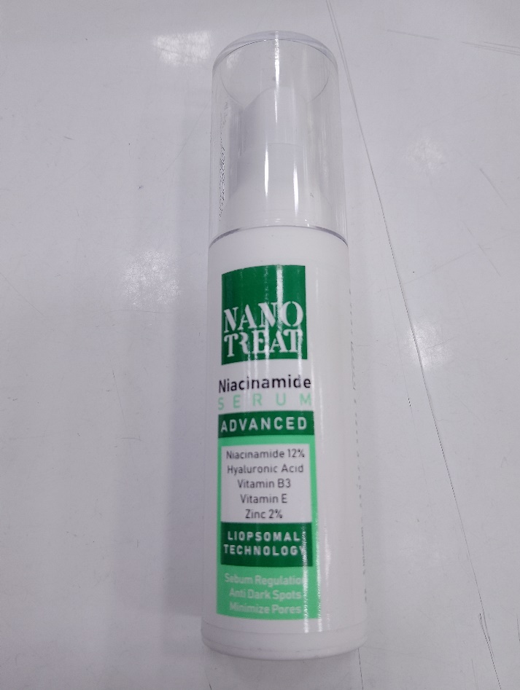

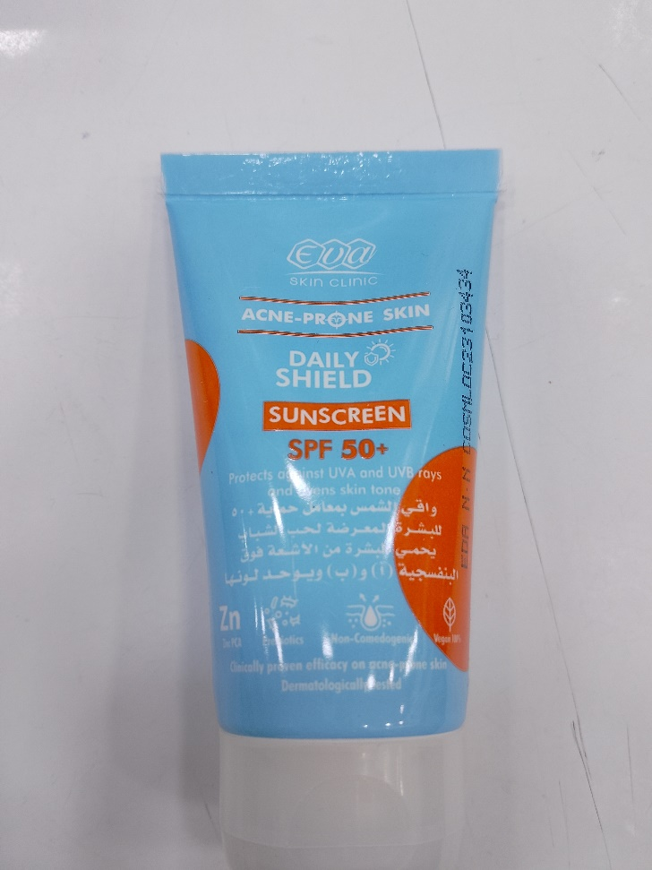
Sensentive and acne prone skin
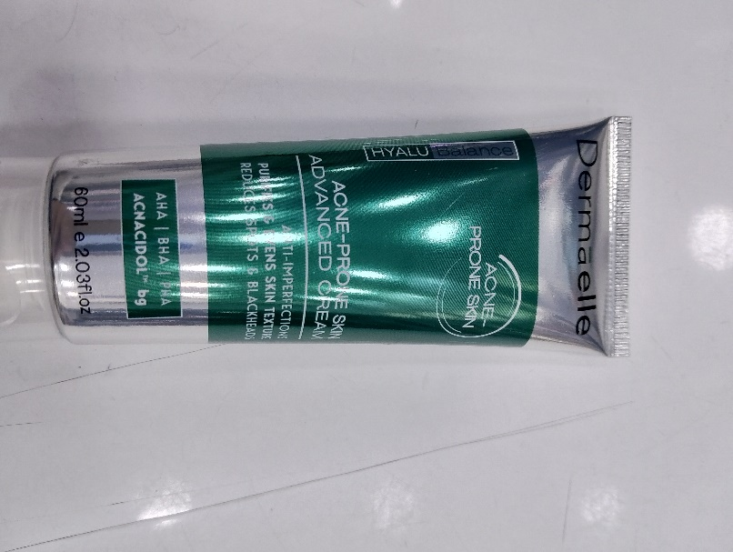

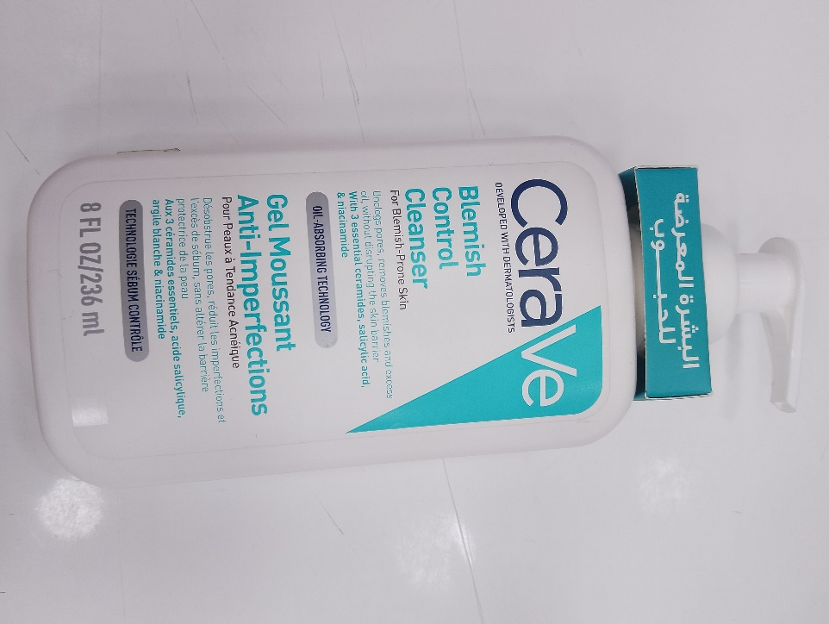
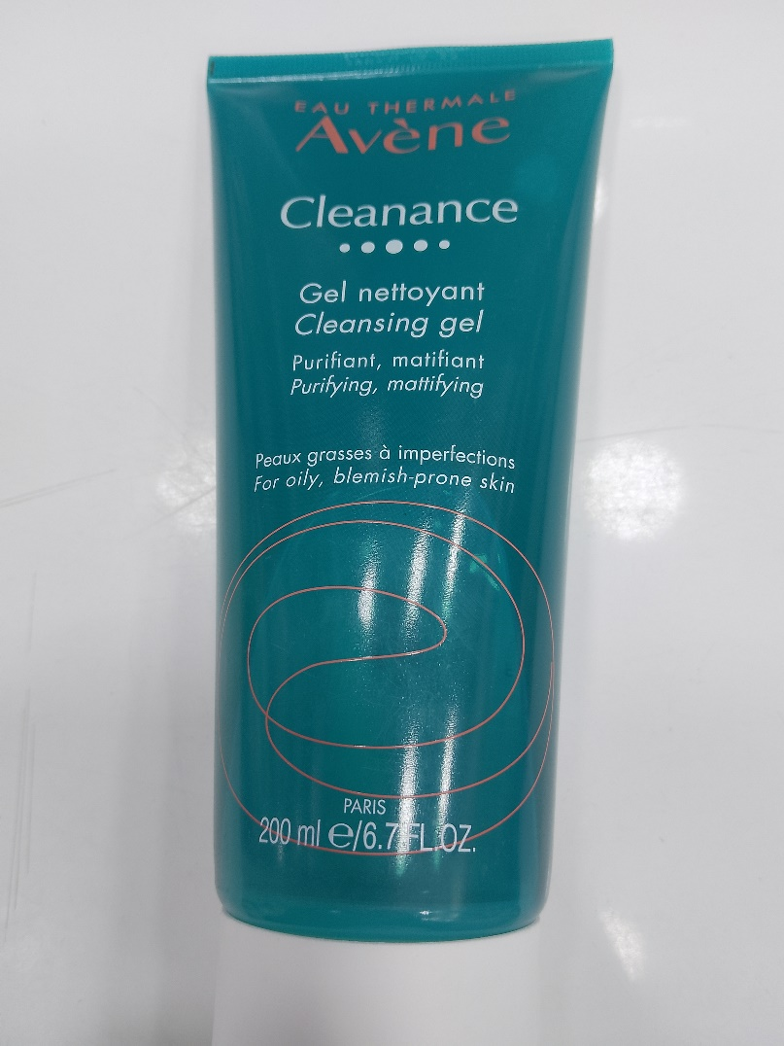

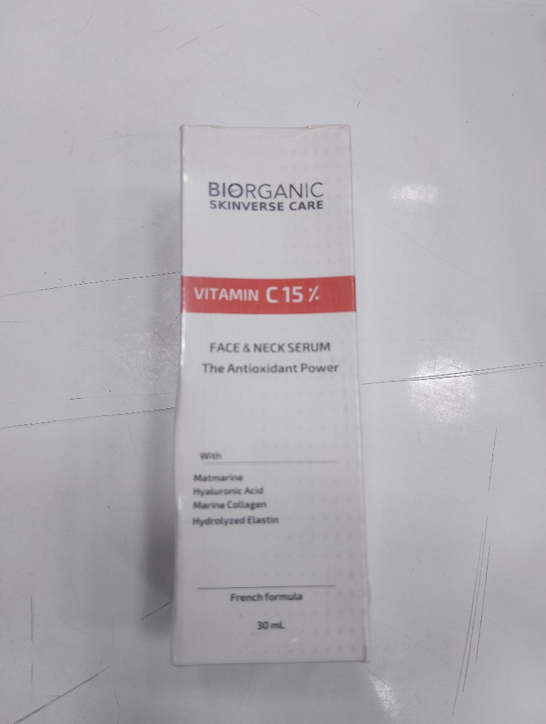
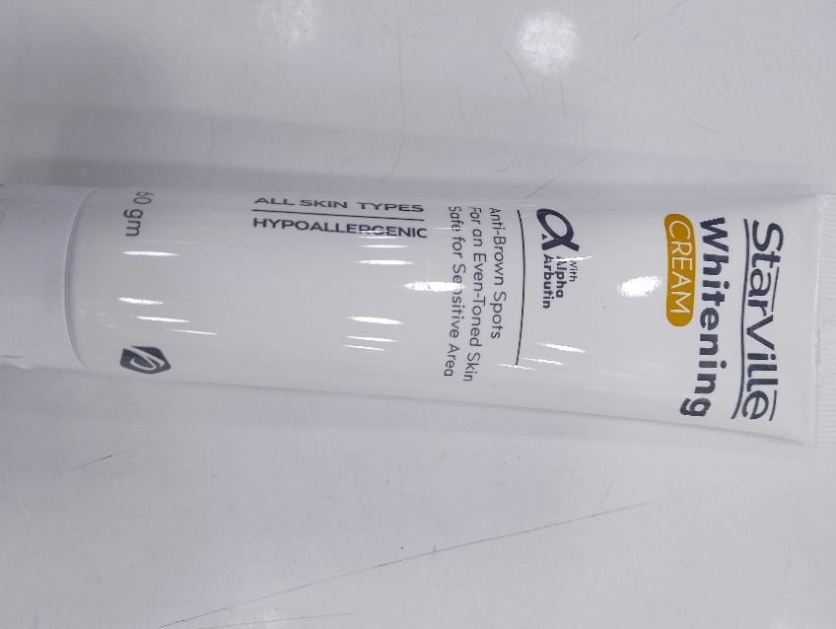
whitening

